UNIVERSITY OF CALIFORNIA
College of Engineering
Department of Electrical Engineering and Computer Sciences

EE 130/230M Prof. Liu & Dr. Xu
Spring 2013
Homework Assignment #9
Due at the beginning of class on Thursday, 4/4/13

Problem 1: Qualitative MOS C-V Curves
C-V curves measured for two MOS capacitors (a and b) with the same gate area are compared below.
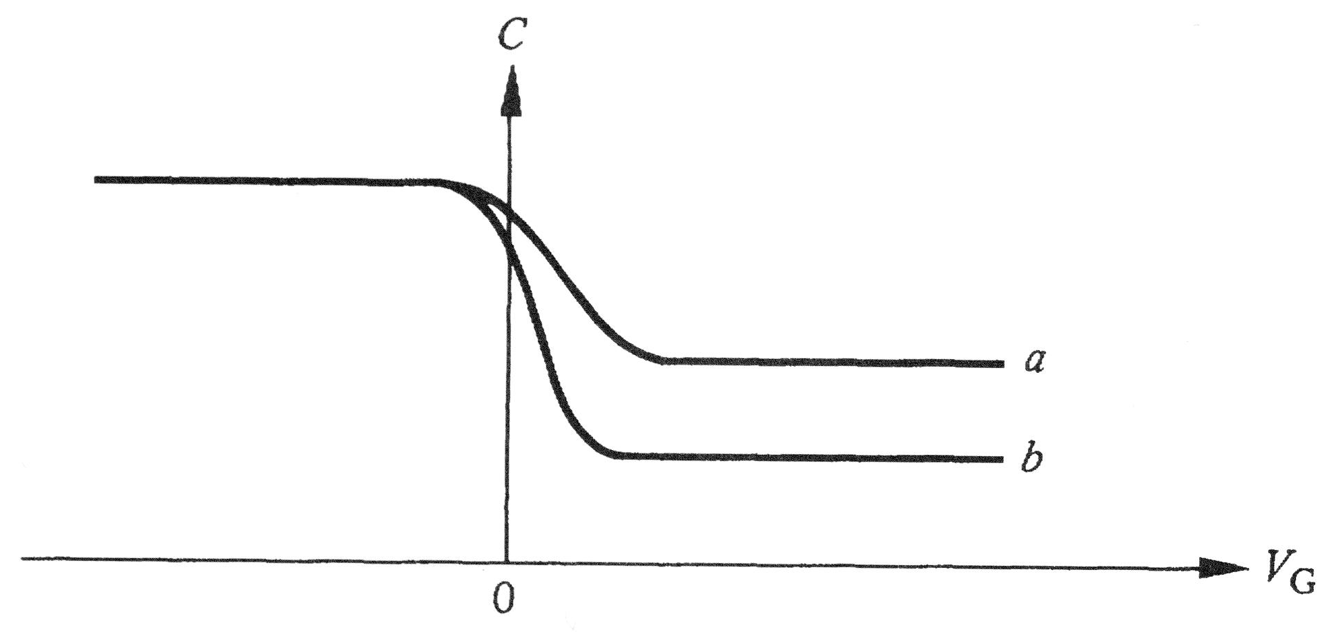
- Is the semiconductor n-type or p-type?
- How do the gate oxide thicknesses for the two capacitors compare? Explain.
- Which capacitor has higher doping in the semiconductor? Explain.

Problem 2: MOS C-V and V_{T} adjustment
Consider an ideal PMOS capacitor of area 100 μm × 100 μm operated at T = 300K. Φ_{M} = 5.2 eV, x_{o} = 3 nm, and N_{D} = 10¹⁷ cm⁻³.
- Calculate the flat-band voltage V_{FB} and the threshold voltage V_{T}. (The electron affinity of Si is χ = 4.05 eV.)
- What is the value of the maximum small-signal capacitance?
- What is the value of the minimum small-signal capacitance?
- Based on your answers above, sketch the high-frequency C-V characteristic and low-frequency C-V characteristic.
- Calculate the required ion implant dose (N_{I} in units of #/cm²) and type (acceptors or donors) needed to increase the magnitude of V_{T} to 0.3 V.

Problem 3: MOS C-V Characteristic
The capacitance vs. gate voltage characteristic of a simple MOS capacitor of area 100 μm × 100 μm is as shown:
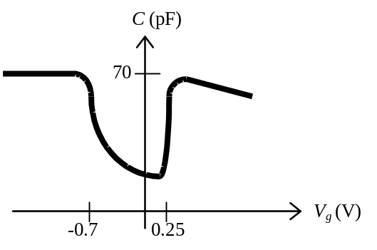
Assume that there are no oxide charges.
- What is the thickness of the gate oxide (SiO₂)?
- Estimate the values of V_{FB} and V_{T}.
- Is the gate material metal or n+ poly-Si? How do you know this?
- Is the substrate lightly doped (<10¹⁸ cm⁻³)? How do you know this?
Problem 4: Effect of Oxide Charge
In modern MOS devices, charges typically exist within the oxide or at its interface with the Si substrate. The different types of charges which may exist are illustrated in the figure below.
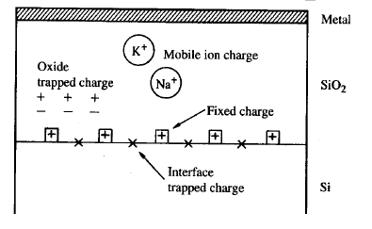
Consider MOS devices with 3 nm thick SiO₂:
- Suppose there is q×10¹¹ cm⁻² trapped charge located 1 nm below the gate electrode interface, and that there is also -q×10¹¹ cm⁻² trapped charge located 1 nm above the Si interface. Will the net impact of these charges on the threshold voltage due to these trapped charges be a positive shift or a negative shift in V_{T}? Explain.
- Suppose the gate oxide contains 10¹¹ cm⁻² sodium ions (Na⁺). If the devices are turned on (gate biased such that the Si surface is inverted) for several hours at elevated temperature, which device (NMOS or PMOS) will show the greater threshold voltage shift from the ideal value? Why?
Note: A positive gate voltage is used to turn on an NMOS device, whereas a negative gate voltage is used to turn on a PMOS device.

