105 Cory

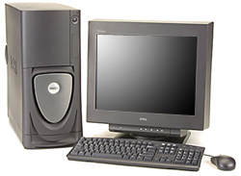

DELL Pentium4 PCs running Windows
"lw105" HP laser printer
PCs donated courtesy of Intel Corp

Users with "EECS" domain Windows accounts can login to the PCs.

See the bulletin board in front of the 1st floor Cory elevators for information.
See http://inst.eecs.berkeley.edu for on-line information.

119 Cory

INTEL High Performance Computing Lab
DELL 670 Pentium4 PCs running Windows
"lw119" HP laser printer
PCs donated by the INTEL Corp

Users with “EECS” domain Windows accounts can login here.
See the bulletin board in front of the 1st floor Cory elevators for information.
See http://inst.eecs.berkeley.edu for on-line information.
199 Cory

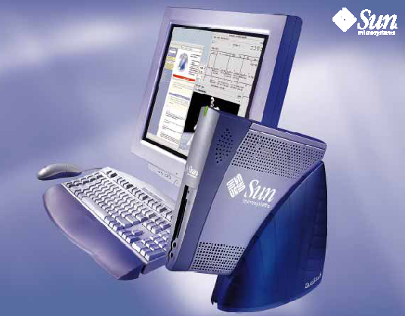 | 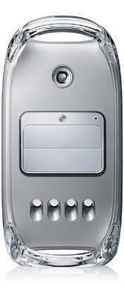
SunRay network appliances  SUN Solaris (UNIX) | Apple Mac G4s  MacOSX (UNIX) | DELL Pentium PCs  Microsoft Windows

Multimedia lab

Users with EECS Instructional UNIX accounts can login to UNIX.
Users with "EECS" domain Windows accounts can login to the PCs.

SUN computers purchased at discount courtesy of Sun Microsystems
PCs donated courtesy of Intel Corp Macs purchased by EECS Instruction
See http://inst.eecs.berkeley.edu for on-line information.

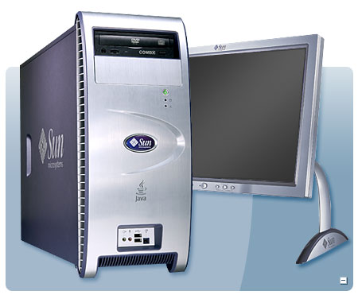

330 Soda
(28) Dell T5500 Workstations with NVidia Tesla C1060 gpus,
Ubuntu Linux.
"lw330" HP laser printer

DELL workstations purchased with generous help from Intel

Users with “EECS” domain Windows accounts can login here.
See the bulletin board near 333 Soda for information.
See http://inst.eecs.berkeley.edu for on-line information.

349 Soda
(4) SUN W1100z PCs w/AMD processors running Windows
"lw349" HP laser printer

SUN workstations purchased with generous help from SUN Microsystems

Users with “EECS” domain Windows accounts can login here.
See the bulletin board near 333 Soda for information.
See http://inst.eecs.berkeley.edu for on-line information.

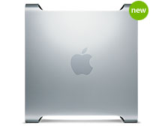
200 Sutardja Dai Hall
The Orchard

30 Apple Mac Pros - thanks to generous help from Apple Computer, Inc

Access is granted to specific classes.

For information, please see
http://inst.eecs.berkeley.edu/labs

271 Soda

SunRay 1 network appliances

Use "lw274" printers in 274 Soda

SunRays donated courtesy of Sun Microsystems

These systems login to nova.cs, a Sun SPARC server running Solaris.
Users with EECS Instructional UNIX accounts can login here.
See the blue bulletin board near 273 Soda for information.
See http://inst.eecs.berkeley.edu for on-line information.
273 Soda

SunRay 1 network appliances

Use "lw274" printers in 274 Soda

SunRays donated courtesy of Sun Microsystems

These systems login to star.cs, a Sun SPARC server running Solaris.
Users with EECS Instructional UNIX accounts can login here.
See the blue bulletin board near 273 Soda for information.
See http://inst.eecs.berkeley.edu for on-line information.

277 Soda

SunRay 1 network appliances

Use "lw274" printers in 274 Soda

Computers purchased at discount courtesy of Sun Microsystems

These systems login to solar.cs, a Sun SPARC server running Solaris.

Users with EECS Instructional UNIX accounts can login here
See the blue bulletin board near 273 Soda for information.
See http://inst.eecs.berkeley.edu for on-line information.

275 Soda
10 Sun Ultra 20s (2.8-GHz Opteron and 2-GB RAM)
24 Dell Precision 340s (2.0-GHz Intel P4 and 1-GB)
running SolarisX86 UNIX
Use "lw274" printers in 274 Soda
PCs donated courtesy of SUN Microsystems and Intel Corp

Users with EECS Instructional UNIX accounts can login here.
See the blue bulletin board near 273 Soda for information.
See http://inst.eecs.berkeley.edu for on-line information.
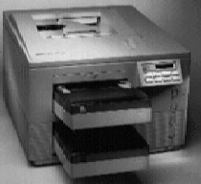

274 Soda - Printer Room
a print group of 2 laser printers
print jobs sent to "lw274" go here

For information about Instructional printers, see
http://inst.eecs.berkeley.edu/Printers
For information about EECS Instructional computer accounts, see
the blue bulletin board near 273 Soda
and http://inst.eecs.berkeley.edu/

310 Davis

SunRay 1 network appliances

"lwdv310" HP laser printer

Computers purchased at discount courtesy of Sun Microsystems

These systems login to dv310.cs, a Sun SPARC server running Solaris.

Users with EECS Instructional UNIX accounts can login here.
See the bulletin board inside 310 Davis for more information.
See http://inst.eecs.berkeley.edu for on-line information.
349 Davis

SunRay 1 network appliances

"lwdv349" HP laser printer

Computers purchased at discount courtesy of Sun Microsystems

These systems login to dv349.cs, a Sun SPARC server running Solaris.

Users with EECS Instructional UNIX accounts can login here.
See the bulletin board inside 349 Davis for more information.
See http://inst.eecs.berkeley.edu for on-line information.

