CS61c Midterm Review (fa06)
Number representation and Floating points
☺ From your friendly reader ☺

Number representation (See: Lecture 2, Lab 1, HW#1)
- KNOW: Kibi (2¹⁰), Mebi(2²⁰), Gibi(2³⁰), Tebi(2⁴⁰), Pebi(2⁵⁰), Exbi(2⁶⁰), Zebi(2⁷⁰), Yobi (2⁸⁰)
- Know the Binary (0b), Octal (0), Decimal, Hexadecimal (0x) representation of numbers.
  - Example: 1111₂ = 17₈ = 15_{ten} = F_{hex}
or 0b1111 = 017 = 15 = 0xF
- Know how to convert from one base to another. Example: 104₅ =4*5⁰+0*5¹+1*5² = 29_{ten}
- Know what is a bit, a Nibble, a Byte, a Word
  - Example: above example uses a Nibble!
- The lecture presents the evolution of number representation: sign and magnitude, one’s complement, two’s complement

  - Sign and Magnitude:
*Left most bit represents the sign (0 == positive, 1 == negative), the rest represents magnitude.
*In order to negate, flip the left most bit.
* Can represent from –(2^{N-1}-1) to 2^{N-1}-1
Cons:
*We have two zeros, namely 0x00000000 and 0x80000000
*Arithmetic is non-trivial
*Number comparison is non trivial ( -2 > -1 )

  - One’s Complement
*Left most bit represents the sign.
*In order to negate, must flip all the bits.
* Can represent from –(2^{N-1}-1) to 2^{N-1}-1
Cons:
* Still have two zeros.
* (x + (-x)) != 0, thus arithmetic is still complicated.

  - Two’s Complement (standard)
*Left most bit represents the sign.
*In order to negate must flip bits and add 1. ➔ -x = flip_bits(x) +1
* Can represent from –2^{N-1} to 2^{N-1}-1
- Unsigned numbers can represent from 0 to 2^{N}-1
- Know overflow: there isn’t enough bits to express a number. E.g: MAX+1 causes overflow
- Big-Endian vs Little-Endian
  - Refers to the order in which BYTES are stored in memory
  - bits of the byte are stored as usual
  - Big-Endian: Big Units first (are on the left)
Example: today’s date representation in big-endian is 06/10/15
  - Little-Endian: Little Units first.
Example: today’s date representation in little-endian is 15/10/06
Floating points (See: Lecture 15 and 16, Lab 6)
- S Exponent Significand | rounding_bits
  - Significand also known as the Mantissa
  - Bias: in order to be able to represent tiny and huge values, usually is 2^{e-1}-1 for normalized numbers, where e is number of bits for E
  - Rounding bits: there are usually extra bits tagged on after the Significand in order to correct for rounding errors when doing arithmetic
  - Single Precision (32 bits): S is 1 bit, E is 8 bits, S is 23 bits, bias = 2⁷-1 = 127
  - Double Precision (64 bits): S is 1 bit, E is 11 bits, S is 52 bits, bias = 2⁸-1 = 1023

- Exponent size vs. Signficand size range vs. precision

- Important to know all types (Norm, zero, Denorm, 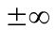, NaN)
Hint: Green sheet can be very useful!
Single Precision discussed below: ( * anything, S is Sign, E is Exponent, M is Mantissa)
  - Norm:
    - S = *, 0 < E < 2⁸-1, M = *
    - Form: (-1)^{S}*2^{(E-127)} *(1+Mantissa)
  - Zero:
    - S = *, E = 0, M = 0
  - Denorm
    - Exponent (implied bias): -126
    - S = *, E = 0, M>0
    - Form: (-1)^{S}*2⁽⁻¹²⁶⁾ *(0+ Mantissa)
    - S = *, E = 2⁸-1 (all ones), M = 0
  - NaN:
    - S = *, E = 2⁸-1 (all ones), M > 0
Double Precision is analogous to above, with exception of E range and the bias (implied bias for Denorm is -1022)

- Floating point addition:
  - See http://www.ecs.umass.edu/ece/koren/arith/simulator/FPAdd/ for a good simulation for floating point addition/subtraction. Make sure you understand what is going on!
  - Steps:
    - Align exponents (biggest exponent wins!)
    - Normalize the result
    - Round
      - Extra bits tagged on at the end of the 32bits (64bits) for rounding error
      - Types: Round to zero, Round to nearest even, Round to , etc.

Somewhat-trivial Questions:
- What is 0xffff ffff in decimal form (you can use *2^{y} in your answer)
  - Unsigned int: _________________

  - Sign and magnitude: _________________

  - One’s complement: _________________

  - Two’s complement: _________________

- J-Lo, who is thirty-six of age (as of fa05), whispers her age to you: “Thirty six”. Was that big-endian or little-endian (mt fa05)

- Let x = 0xffff ffff. What is the decimal value (if any) using Single Precision floats?

- Let x = 0x0040 0000. What is the decimal value (if any) using Single Precision floats?

- What is a mebi?

Conceptual/Midterm type Questions:
- Let x = 0x4000 0000 and y = 0x0040 0000 be floats. What is x+y?

- What is minimum positive float x such that x + 1 = x (You’ve done this before in lab, and this has been on the Midterm before!)

- True/False: Float arithmetic is associative. i.e. (x+y)+z = x+(y+z) . If not, show a counterexample.
- Let float x=2²⁰, find float y such that x+y have 0xb11 in the rounding bits on the alignment step (assume there are 2 such bits)
i.e. x = 1.********** ********** *** | 00 * 2^{n}
y = *.********** ********** *** | 00 * 2^{n}
x + y = *.********** ********** *** | 11 * 2^{n}

- Compute x+y, using truncation.

- Compute x+y using “Round to zero”

- Compute x+y using “round to Plus Infinity”

From Dan’s previous Midterm (fa05)
(Perhaps b should be done before a ☺)

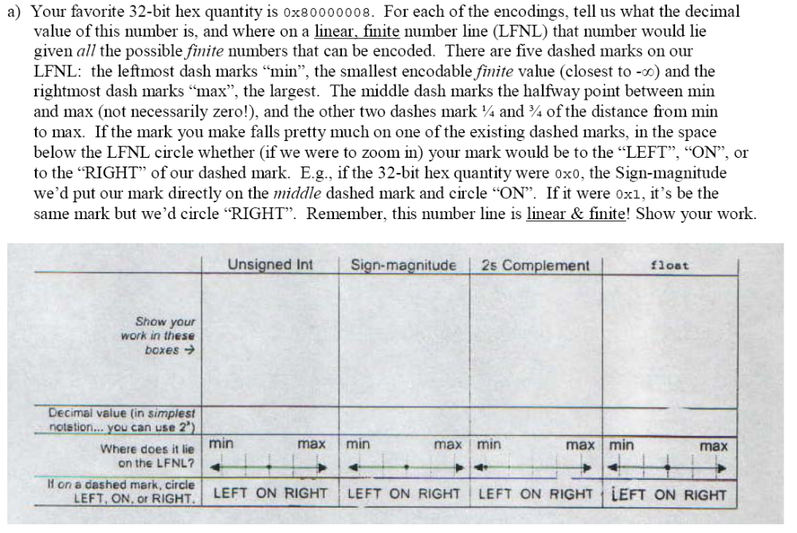

b) What is min, max, and positive min (greater than 0) for each of the types specified above?
Type: | Min | max | positive (normalized) min (>0)
Unsigned int
Sign-Magnitude
2s complement
Float
c) What is the largest integer that a float/double can store?

d) What is the largest integer that float/double can’t store?

