CS61c Midterm Review (fa06) answers
Number representation and Floating points
Somewhat-Trivial Questions:
- What is 0xffff ffff in decimal form (you can use *2^{y} in your answer)
  - Unsigned int: ____2³²-1___
  - Sign and magnitude: ____-2³¹-1__
  - One’s complement: ____ -0____
  - Two’s complement: ____-1_____
- J-Lo whispers her age to you: “Thirty six”. Was that big-endian or little-endian (mt fa05)
Big-Endian
- Let x = 0xffff ffff. What is the decimal value (if any) using Single Precision floats?
NaN .
- Let x = 0x0040 0000. What is the decimal value (if any) using Single Precision floats?
2^{-127 .}
- What is a mebi? 2²⁰ .
- Let x = 0x4000 0000, y = 0x3f800000. What is x+y? (truncate)
3 .
Conceptual/Midterm type Questions:
- Let x = 0x4000 0000, y = 0x0040 0000. What is x+y? (truncate)
2 .
- What is minimum positive float x such that x + 1 = x (You’ve done this before in lab, and this has been on the Midterm before!)
X = 2²⁴ = 0b4b800000
- True/False: Float arithmetic is associative. i.e. (x+y)+z = x+(y+z) . If not, show a counterexample. X+1+1 = 2²⁴+1+1
- Let x = Mebi, find y such that x+y have 0xb11 in the rounding bits on the alignment step (assume there are 2 such bits)
i.e. x = 1.********** ********** *** | 00 * 2^{n}
y = *.********** ********** *** | 00 * 2^{n}
x + y = *.********** ********** *** | 11 * 2^{n}
x = 2²⁰
x = 1*2²⁰⁺¹²⁷ = 0x4980 0000
easiest to find x+y = 1.000….0 | 11 * 2²⁰
thus y = 0.00….0 | 11 * 2²⁰ = 2²⁰* (2⁻²⁴ +2⁻²⁵)
= 2⁻⁴*2⁻⁵
= 2⁻⁴* (1 + ½)
y = 0x3dc0 0000
- Compute x+y, using truncation.
x+y = 1.000….0 | 11 * 2²⁰
= 1.000….0 * 2²⁰
= 2²⁰ = 0x4980 0000
- Compute x+y using “Round to zero”
x+y = 1.000….0 | 11 * 2²⁰
= 1.000….0 * 2²⁰
= 2²⁰ = 0x4980 0000
- Compute x+y using “round to Plus Infinity”
x+y = 1.000….0 | 11 * 2²⁰ = 2²⁰ = 0x4980 0000
= 1.000….1 * 2²⁰
= (1+2⁻²³) * 2²⁰
= 2²⁰ + 1/8 = 0x4980 0001
From Dan’s previous Midterm (fa05)
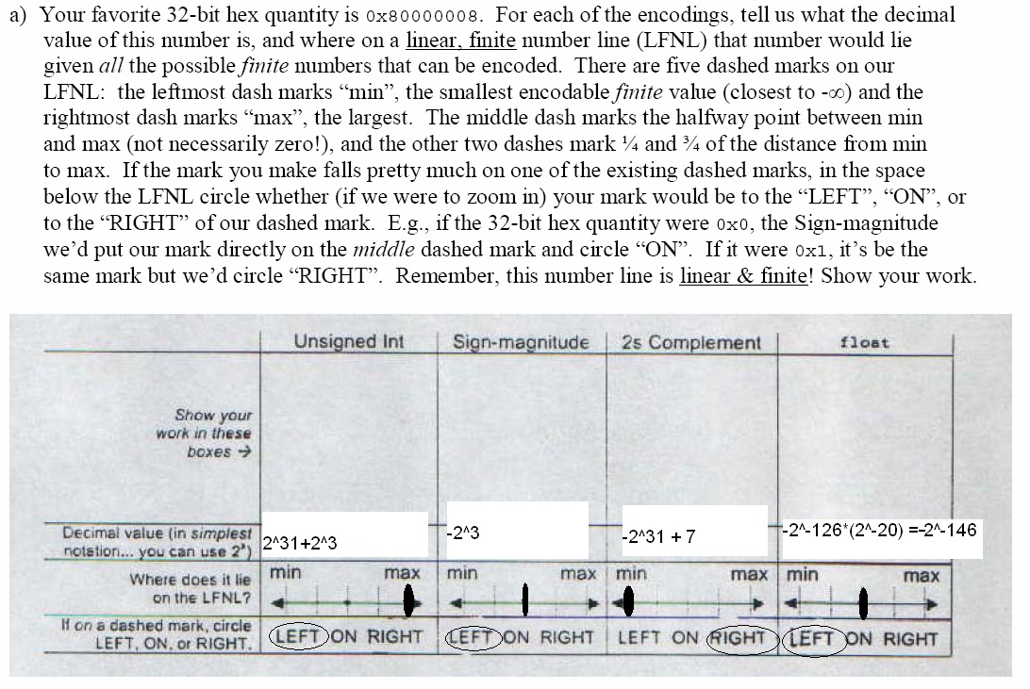
b) What is min, max, and positive min (greater than 0) for each of the types specified above?
Type: | Min | max | positive (normalized) min (>0)
Unsigned int | 0 | 2³²-1 | 1
Sign-Magnitude | -(2³¹-1) | 2³¹-1 | 1
2s complement | -2³¹ | 2³¹-1 | 1
Float | 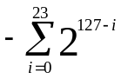 | 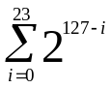 | 2⁻¹²⁶
c) What is the largest (unsigned) integer that a float/double can store?
float: 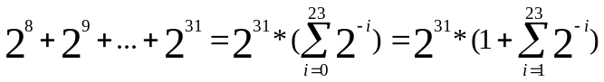=0x4f7f ffff
double: 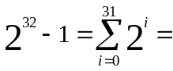0x41e ffff fffc 0000 0000 0000 0000 0000
d) What is the largest (unsigned) integer that float/double can’t store?
float: 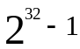 double: none.

