If you only need a Web browser (CS10), you can just login as Guest.
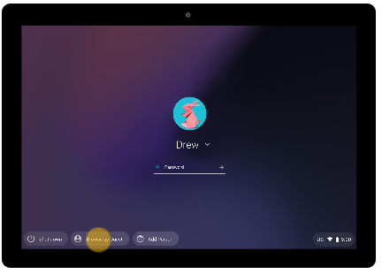
To display the Guest login window, click on “Browse as Guest” in the lower left corner:

Enter the URL in the Chrome browser, such as http://snap.berkeley.edu.

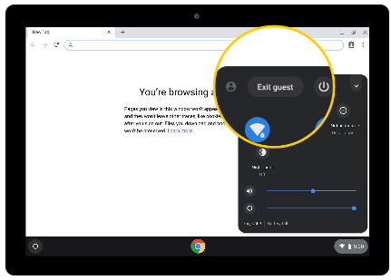
You can log yourself (or the previous user) out by clicking on the lower right button (with the time on it) and then clicking on “Exit Guest”:

If you need to run an app such as Secure Shell or Remote Desktop (CS61BL), you must login as yourself (click on “Add Person” not “Browse as Guest”), and ensure that the Chromebook is using the AirBears2 (not CalVisitor) wireless network:
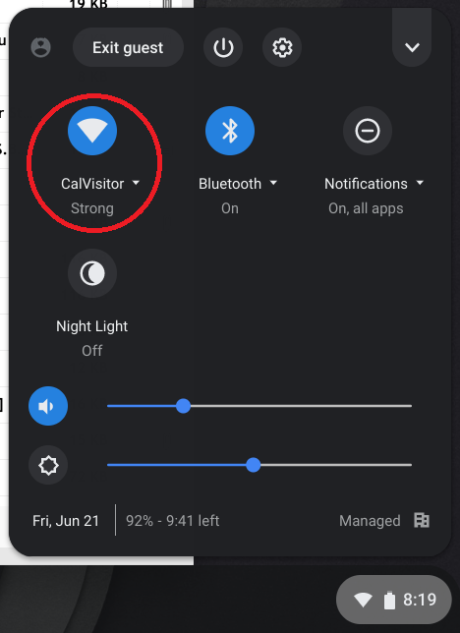
Click on the lower right button with the time on it. If you see CalVisitor, click on it:

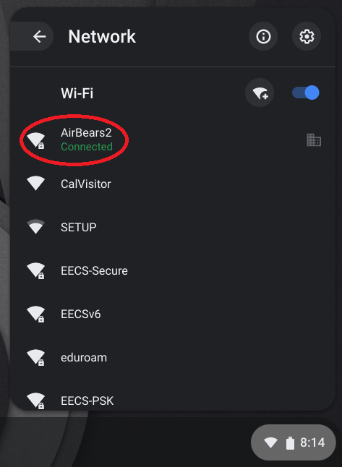
Click on AirBears2 and wait for the network connection to reset:

To download and install Secure Shell, use Chrome to search for “Secure Shell App – Google Chrome”. With Secure Shell, you can login to EECS Linux servers with a text-only shell. If your EECS account is “cs61bl-aaa”, you can login to a server such as cedar.cs, ie “cs61bl-aaa@cedar.cs.berkeley.edu”.
To download and install Remote Desktop, use Chrome to search for “Chrome Remote Desktop - Chrome Web Store”. Additional information will be provided by inst@eecs.berkeley.edu if needed.

