University of California at Berkeley
College of Engineering
Department of Electrical Engineering and Computer Science

EECS 150 Original Lab By: J.Wawrzynek and N. Weaver
Fall 1999 Later revisions by R. Fearing, and J. Shih
Xilinx Foundation 1.5 version: T. Smilkstein

Lab 2
Finite State Machine

Objectives

You will enter and debug a Finite State Machine (FSM). Using our definition of the problem and logic equations specifying the FSM’s operation, you will enter your design in the schematic editor and simulate it with the logic simulator.

Prelab

- Get a partner from your lab section!
- Complete your IN1 (INput 1) and IN2 (INput 2) blocks
- Write a .cmd (command) file to test your CLB (Combinational Logic Block).
- Write one single .cmd file with all the FSM test scenarios specified in the check-off sheet.
- Do as much as possible before your scheduled lab time. There is much to do in this lab. Some can be done on paper; the remainder can be done on the computers outside of lab time.

High-level Specification

You are building the controller for a 2-bit serial lock used to control entry to a locked room. The lock has a RESET button, an ENTER button, and two two-position switches, CODE1 and CODE0, for entering the combination. For example, if the combination is 01-11, someone opening the lock would first set the two switches to 01 (CODE1 = low, CODE0 = high) and press ENTER. Then s/he would set the two switches to 11 (CODE1 = high, CODE0 = high) and press ENTER. This would cause the circuit to assert the OPEN signal, causing an electromechanical relay to be released and allowing the door to open. Our lock is insecure with only sixteen different combinations; think about how it might be extended.
If the person trying to open the lock makes a mistake entering the switch combination, s/he can restart the process by pressing RESET. If s/he enters a wrong sequence, the circuitry would assert the ERROR signal, illuminating an error light. S/he must press RESET to start the process over.
In this lab, you will enter a design for the lock’s controller in a new Xilinx project. Name this lab “lab2”. Make RESET and ENTER inputs. Simulate by pressing the ENTER button by forcing it high for a clock cycle. Use a two-bit wide input bus called CODE[1:0] for the two switches. (Information on how to use buses will be given later in this handout). The outputs are an OPEN signal and an ERROR signal.
Figure 1 shows a decomposition of the combination lock controller, whose inputs and outputs are:

Input Signal Description
RESET Clear any entered numbers
ENTER Read the switches (enter a number in the combination)
CODE[1:0] Two binary switches
Output signal Description
OPEN Lock opens
ERROR Incorrect combination
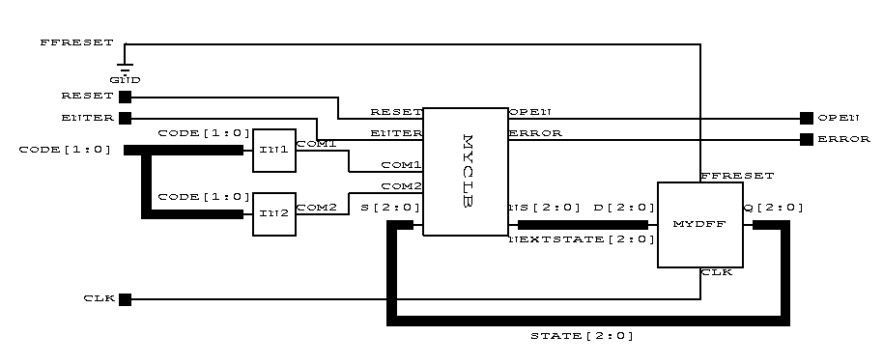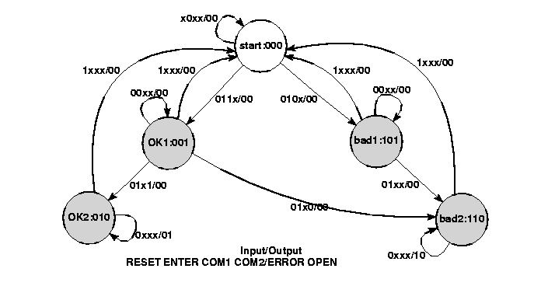 Figure 1: Controller for the combination Lock

OPENLOCK
Figure 2: State Transition Diagram

Low-level specification

4.1 IN1 (INput 1) and IN2 (INput 2)
Blocks IN1 and IN2 process the input signals COM1 (COMpare 1) and COM2 (COMpare 2) into a simpler form for the FSM. Specifically, COM1 is asserted when CODE[1:0] is the combination’s first number. Similarly, COM2 is asserted for the second number. Partitioning the circuit in this way makes the combination easy to change.
Choose your own combination; the two numbers must be different.
This should be a simple block. Use a few AND gates and inverters.
4.2 MYCLB
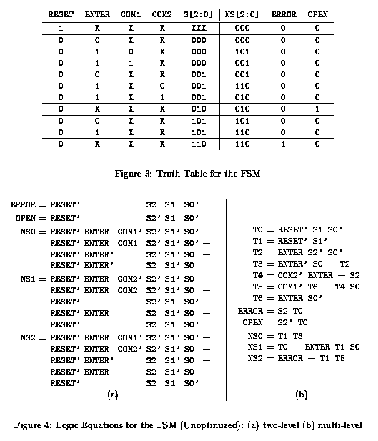The MYCLB (MY Combinational Logic Block) block takes RESET, ENTER, COM1, COM2, and present state and generates OPENLOCK and ERROR, as well as the next state. Figure 2 shows the state transition diagram, a Mealy machine since the transitions are labeled with both inputs and outputs. The white circle denotes the rest state (i.e., the state the machine starts in).

OPENLOCK

OPENLOCK
=

OPENLOCK S2’ T0
=

By writing an “AND” term describing each row where an output is 1 and ORing these together, it’s easy to obtain a set of equations implementing the table shown in Figure 3.
Translating a state transition diagram to a truth table is mechanical: Write a row for each transition. In Figure 4a, I’ve collapsed a few rows together by noting that when RESET is 1, the outputs and next state are the same for all states. Note RESET’ means NOT RESET.
Implementing the equations of Figure 4a as written would be inefficient, so we introduce intermediate variables T0, ..., T6 as shown in Figure 4b. Make symbol and schematic for MYCLB using the equations in Figure 4b.
4.3 MYDFF

(MY D Flip-Flops)
Create a block called MYDFF that contains three D flip-flops (one for each state bit) with an asynchronous clear hooked to a pin called FFRESET (Flip-Flop RESET). The flip-flops you should use are the FDC (D Flip-flop with asynchronous Clear) flip-flops. Externally, connect FFRESET to 0 (i.e., not resetting), but during simulation you can force this to 1 to reset every flip-flop.

Buses

Buses are supported by the Xilinx software. Buses are collections of wires drawn as one by clicking on the “Draw Buses” icon and drawing as if you were drawing a wire.
As with wires, to end a bus you click on the right mouse button and select a method to end the bus. You have a choice of “Add Bus Terminal”, “Add Bus Label”, or “Add Bus End”.
“Add Bus Terminal” is how you want to end buses that will be connected to a symbol’s pins (inputs and outputs) when drawing a symbol’s schematic (reviewing how input and output wires were drawn in symbols in lab 1 may help make this easier to understand). Remember to specify whether the terminal is an input or output terminal. Also you will be required to input a name and how many wires the bus is made up of. It doesn’t matter whether you set the range from, say, for an eight-bit bus, 7 to 0, or from 0 to 7, but it is necessary to be consistent in your all of your labeling. In labs where you’re using a TA schematic, it will usually be necessary to use 7 to 0. For this lab we will not use complex buses but they may be useful to you when doing later labs and when doing the project. Complex buses allow you to combine multiple buses and single wires into one bus.
“Add Bus Label” is how to end all other buses. As you did when adding a terminal to a bus, you will need to specify a name and range when adding a bus label.
“Add Bus End” ends the bus without naming it. To name the bus later, edit an existing label, or change a bus’s attributes, double click on the bus while in the “Select” mode to bring up the bus’s attribute dialog.
To “break out” a wire from a bus, draw a wire and combine the bus name and the number of the wire to form the new wire’s name. For example, if you had a bus called DATA that was eight bits wide, to access the wire that has the lowest bit of the bus, you would draw a wire and name it DATA0. It is also possible to “break out” sub buses, e.g, DATA[5:2]. Buses between pins with the same (bus) width do not need to be named, but any bus which you want to break a wire out of must be named.
The “Draw Bus Taps” function will be helpful when you need to break out many wires, but won’t be necessary for this lab.
Bussing related signals makes the circuit easier to read and simulate. When using the command window or writing a command file using the script editor, as you did in lab1, writing:
vector data DATA[7:0]
(or: v data DATA[7:0] ) makes the signals DATA7, DATA6, … DATA0 into a vector called data, which can be treated like any other signal: you can watch vectors and set their values. Use the assign command to set a vector’s value. E.g.: a data 3e\h (hexadecimal) or a data 001111110\b (binary).

Forcing Internal Signals

In addition to inputs, the logic simulator allows you to force internal signals, those normally driven by components, to particular values. For example, you’ve tied FFRESET to 0, but it can be set high simply by typing:
h FFRESET
which will reset the state bits to zero after you simulate for a step. Use
r FFRESET
to release the signal – return it to its default.
A similar trick lets you set the state to anything you want. Simply set NEXTSTATE[2:0] to the state you want, clock the FSM, and then release NEXTSTATE[2:0].

Clocks

You can define a clock (an input signal that changes periodically) in your script file or in the command window. For example,
clock clk 0 1
makes the clock signal clk oscillate as the circuit is simulated. To simulate for a single clock period, use cycle instead of sim.

Command and Log Files

File → Run Script File… loads a script file and runs each line of it as if you were typing each of those lines in the command window. The most convenient way to create a script file is to use the Tools → Script Editor. If you want to use another editor you can, but if you do, make sure to save the file as plain text and that the file extension is .cmd.
To save a log of the commands you use in your session, you can create a transcript of your work using the command log. Start a log with log filename.log, and end a log by typing log alone.

Naming

- The Xilinx software, DOS, and Windows is case-insensitive, somewhat, although we’ve used all caps for signals throughout this handout.
- You may use letters, numbers, and underscores (_) in filenames. The period (.) may only appear in certain places (e.g., yourfile.cmd, etc). Avoid other punctuation.
- You may use letters, numbers, and underscores in labels, but avoid other punctuation.
- Do not use names already used by components in other libraries. For example, do not call your combinational logic block CLB since there is already a component with that name in the xc4000e) library.

Name: _______________________________ Name: _____________________________________
Lab Section (Check one)
M: AM PM T: AM PM W: AM PM Th: PM

Checkoffs

10.1 Design the IN1, IN2, and MYCLB blocks. Enter it using the schematic editor using only components from the XC4000E library (This is very important - In the next lab you will be putting this on a Xilinx chip and only components from the XC4000E library will work). You’ll probably use the AND2, AND3, OR2, OR3, INV, FDC, and GND components.

TA: _____________(20%)

10.2 Make a test script for your CLB and run it. Show the TA your script and that the output is correct.

TA: _____________(20%)

10.3 Design your state register using D-flip-flops. Call it MYDFF.

TA: _____________(10%)

10.4 Wire up the FSM using the CLB and state register you designed.

TA: _____________(20%)

  - Write a command script to simulate the following scenarios:

- A successful entry of the combination.
- A successful entry of the combination with cycles of pauses between when ENTER is asserted.
- A sequence with the first combination number entered wrong.
- A sequence with the second combination number entered wrong.
- A sequence with the both combination numbers entered wrong.
- RESET is asserted after entering just the first number correctly.
- RESET is asserted after entering just the first number incorrectly.

Create a log file to show your TA.

TA: _____________(30%)

10.6 Turned in on time

TA: _____________(full credit (100%))

10.7 Turned in one week late

TA: _____________(half credit (50% x points))

