4)
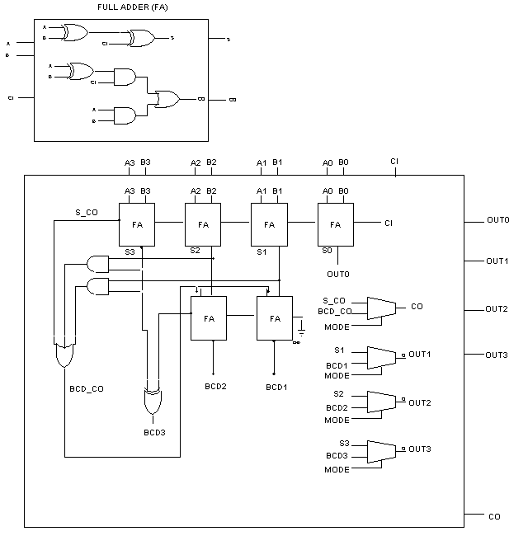

5a)
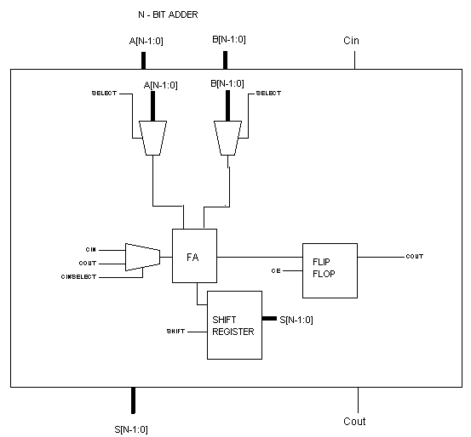

Signals: SHIFT, CinSELECT, SELECT, CE

5b)

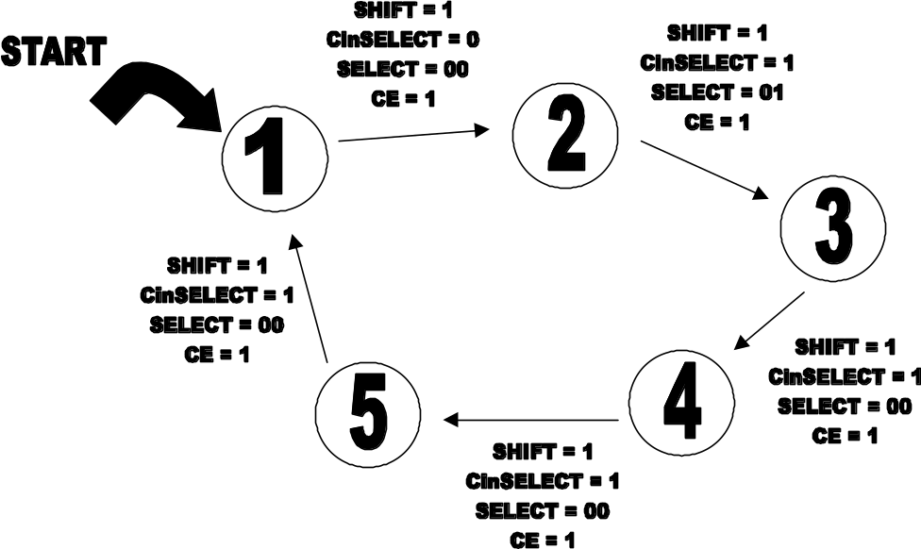

5c) A[3:0] = 0110
B[3:0] = 1100
Cin = 0

Step 1: SELECT = 0
CinSELECT = 0
SUM = 0000
Cout = 0
Step 2: SELECT = 1
CinSELECT = 1
SUM = 1000
Step 3: SELECT = 2
CinSELECT = 1
Cout = 1
SUM = 0100
Step 4: SELECT = 3
CinSELECT = 1
SUM = 0010
Cout = 1

