Laboratory 4: Biasing of MOS Transistors

Preliminary Exercises

MOS Biasing circuits
When using a MOS device as an amplifier, a biasing circuit is required to set the drain current in the correct region of operation. A good biasing circuit will provide stable DC current while maximizing the room for the device voltage swing.
Three possible bias circuits are shown in Figure PL4.1. For each circuit, choose the resistor values to bias the circuit with I_{D} = 50 mA, for V_{DD} = 10V. The NMOS device is BS170, which has the following characteristics (taken from the datasheet):
$$V_{t}=2.0 V \\ k_{n}=100 \frac{mA}{V^{2}}$$
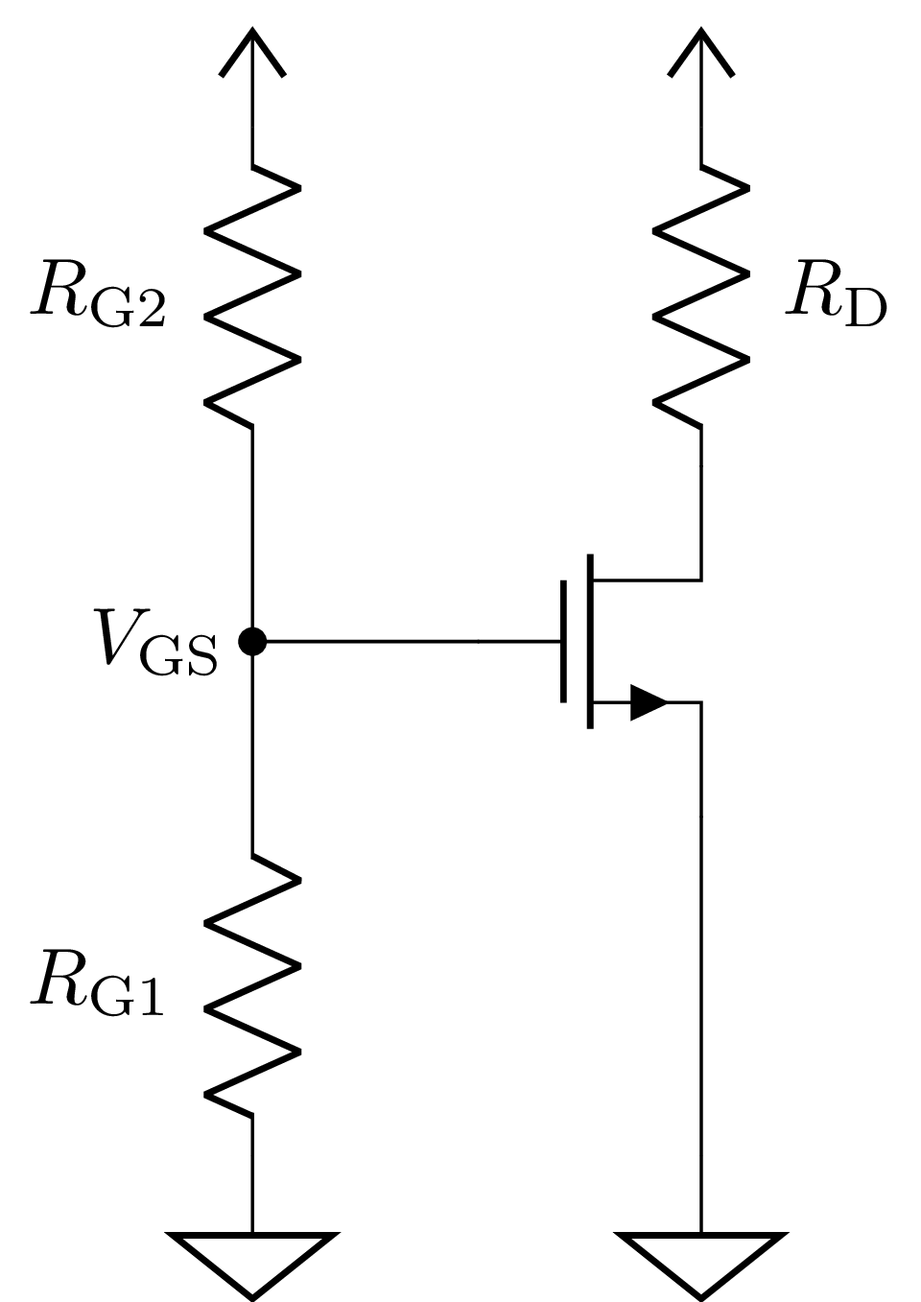 | 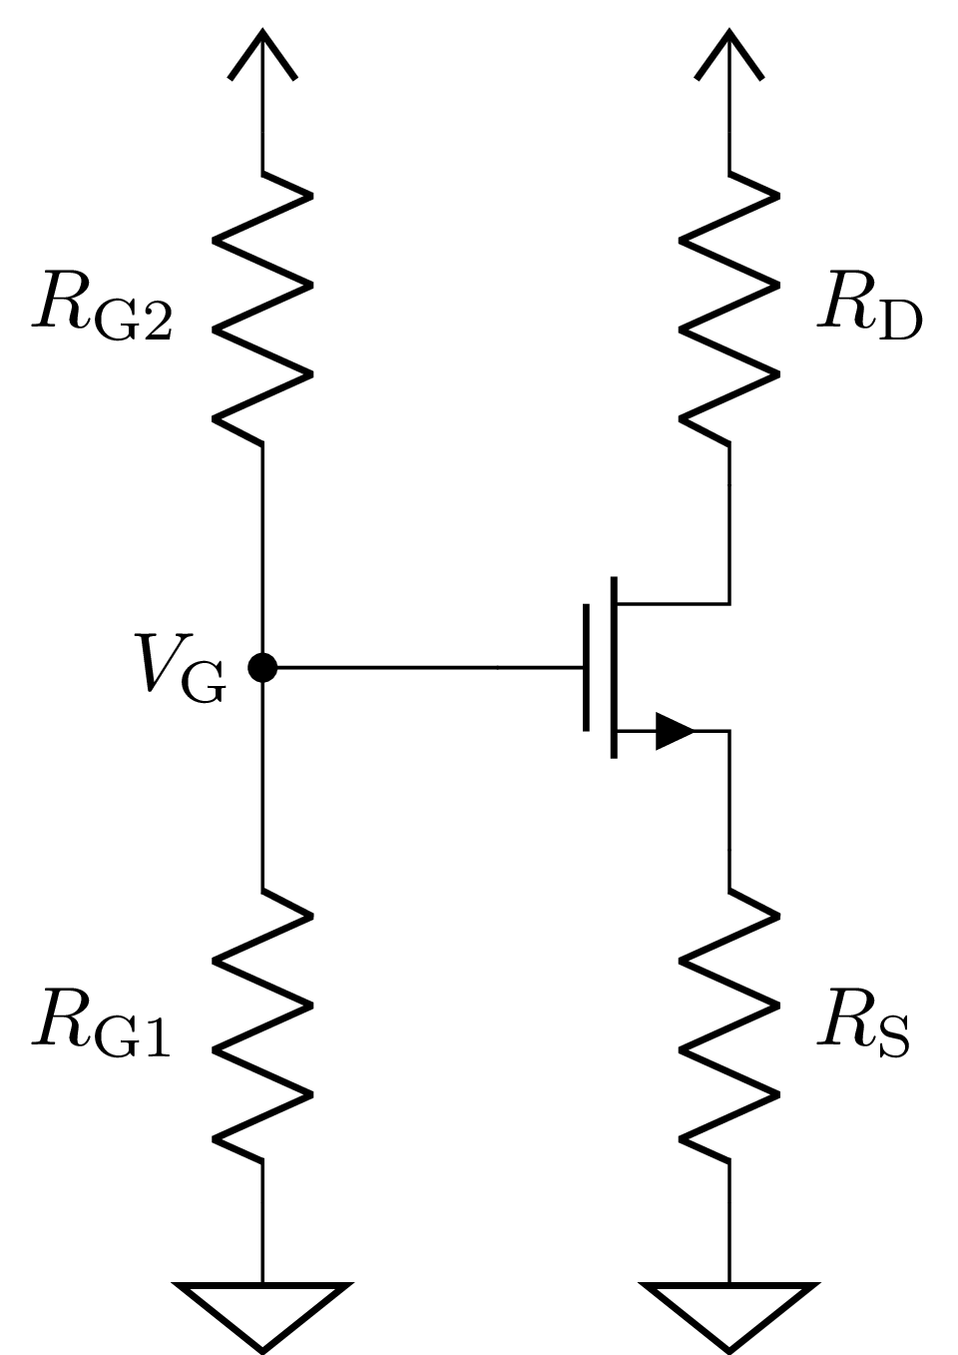 | 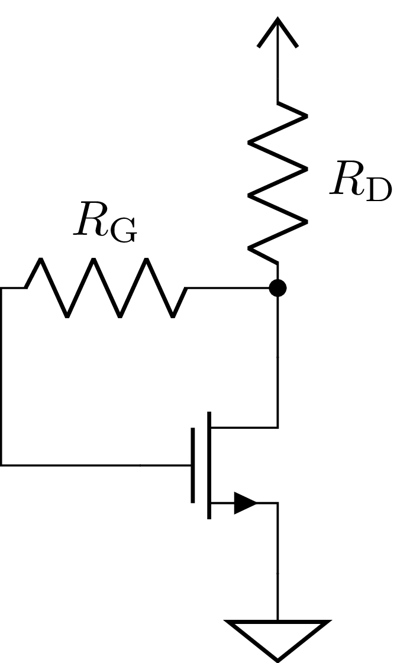
(a) | (b) | (c)
Figure PL4.1: Different MOS biasing circuits. (a) Setting V_{GS} with a resistor divider. (b) Setting V_{G} with feedback from a source resistor. (c) Gate feedback from drain terminal
Here are a few useful hints for designing the circuit:
- For circuits (a), choose R_{D} so that both R_{D} and V_{DS} drop V_{DD}/2 at the DC bias current.
- For circuit (b), chose R_{D} and R_{S} so that they and V_{DS} each drop V_{DD}/3 at the DC bias current.
- In saturation, the drain current varies as the square of the overdrive voltage:
$$I_{D}=\frac{1}{2}k_{n}(V_{GS}-V_{t})²$$
- For circuit (c), R_{G} is typically large (e.g. 10 MΩ).

Resistive touch sensor amplifier
Figure PL4.2(a) shows a simple resistive touch sensor.
- Why do we need the transistor? Can we have the same functionality using the circuit in Figure 3(b)?
- What are the functions of R₁ and R₂?
- What is the status of the LED before and after touching for (a)? Why?
- Using the V_{t} and k_{n} values mentioned previously, what is the I_{D} current before and after touching to the sensor? Show your calculations.

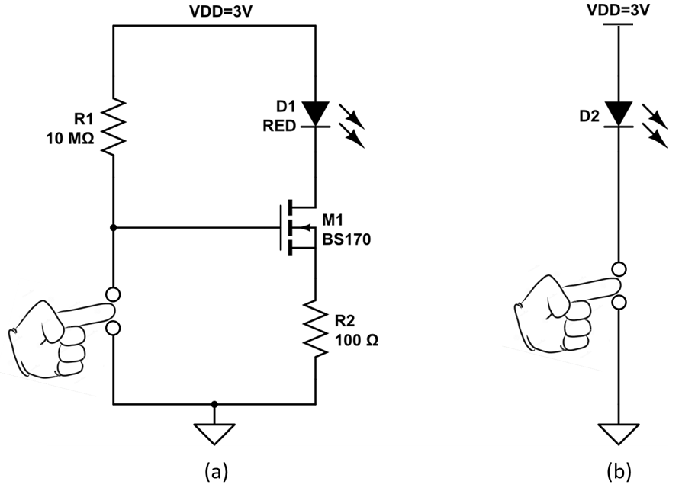
Figure PL4.2: Resistive touch sensor.

Laboratory 4: Biasing of MOS Transistors
Results Sheet for Preliminary Exercises
NAME: LAB SECTION:

MOS biasing circuits
- Setting V_{GS} with a resistor divider

R_{D} = ____________

R_{G1} = ____________

R_{G2} = ____________

- Setting V_{G} with feedback from a source resistor.

R_{D} = ____________

R_{S} = ____________

R_{G1} = ____________

R_{G2} = ____________

- Gate feedback from drain terminal

R_{D} = ____________

R_{G} = ____________

Resistive touch sensor amplifier
- ____________

- ____________

- ____________

- ____________

Laboratory 4: Biasing of MOS Transistors
Laboratory Exercises
INTRODUCTION
Objectives
- Characterize the BS170 MOS transistor
- Design and compare different MOS biasing circuits
- Use a MOS transistor as an amplifier for a resistive touch sensor
Summary of Procedures
- Trace a I_{D}-V_{G} curve of the BS170 transistor
- Build different MOS biasing circuits
- Compare the stability of the MOS biasing circuits with a second transistor
- Build a resistive touch sensor amplifier
Materials Required
- Multi-meter
- Power supply
- Breadboard
- BS170 transistor
- Assorted resistors
- Potentiometer
- LED
PROCEDURE

I_{D}-V_{G} characterization
For this step, we will verify the parameters given in the BS170 datasheet by doing an I_{D}-V_{G} sweep on the HP 4145/4155B.
- Connect the transistor’s gate, drain and source to three difference SMU channels
- Setup the measurement to sweep the gate voltage while measuring the drain current. An example channel definition is given in Figure L4.1. Use a compliance of 100 mA, a drain voltage of 5 V, and sweep the gate voltage from 0 V to 5 V in steps smaller or equal to 0.1 V.
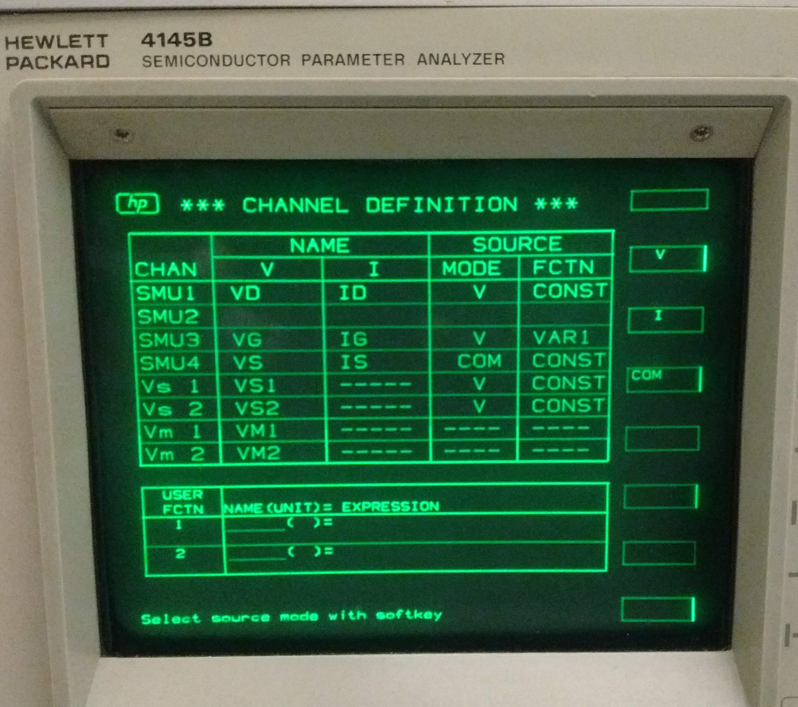
Figure L4.1: Channel definition for I_{D}-V_{G} sweep

- Plot the drain current versus the gate voltage on a linear scale. What is the threshold voltage? What is the required voltage to get 50 mA of drain current? Calculate the k_{n} for this transistor.

MOS biasing circuits
In this section, three biasing circuits will be studied. In particular, they will be tested on two different transistors to compare their stability.
- Build the following circuit, with V_{DD} = 10 V. Use a 20 kΩ potentiometer for R_{G1}, and use the R_{D} value from the prelab. Measure R_{D} precisely.
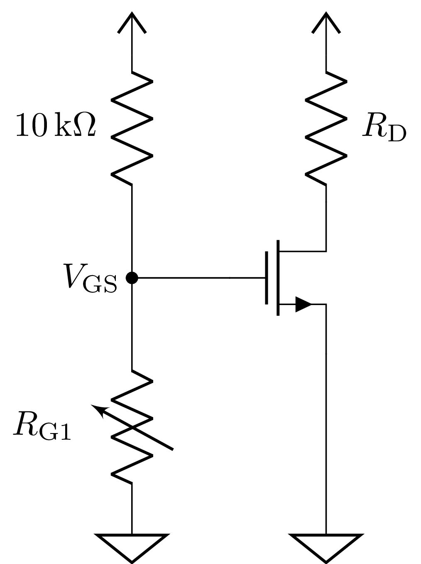
Figure L4.2: Biasing by setting the gate voltage

- Tune the potentiometer to obtain a drain current of 50 mA (by measuring across R_{D}). Is it easy to achieve accurate control? As the transistor heats up with time, does the current stay stable?
- Measure the potentiometer R_{G1} and the gate resistor R_{G2} and determine V_{GS} for this condition. Compare with the measurement in part 1.
- Replace the transistor with a different one without touching the potentiometer. Did the drain current change compared to the other transistor?
- Build the second biasing circuit, by adding a source resistor, calculated from the prelab (make sure you change R_{D} if it has a different value from the first circuit). Measure R_{S} and R_{D} precisely.
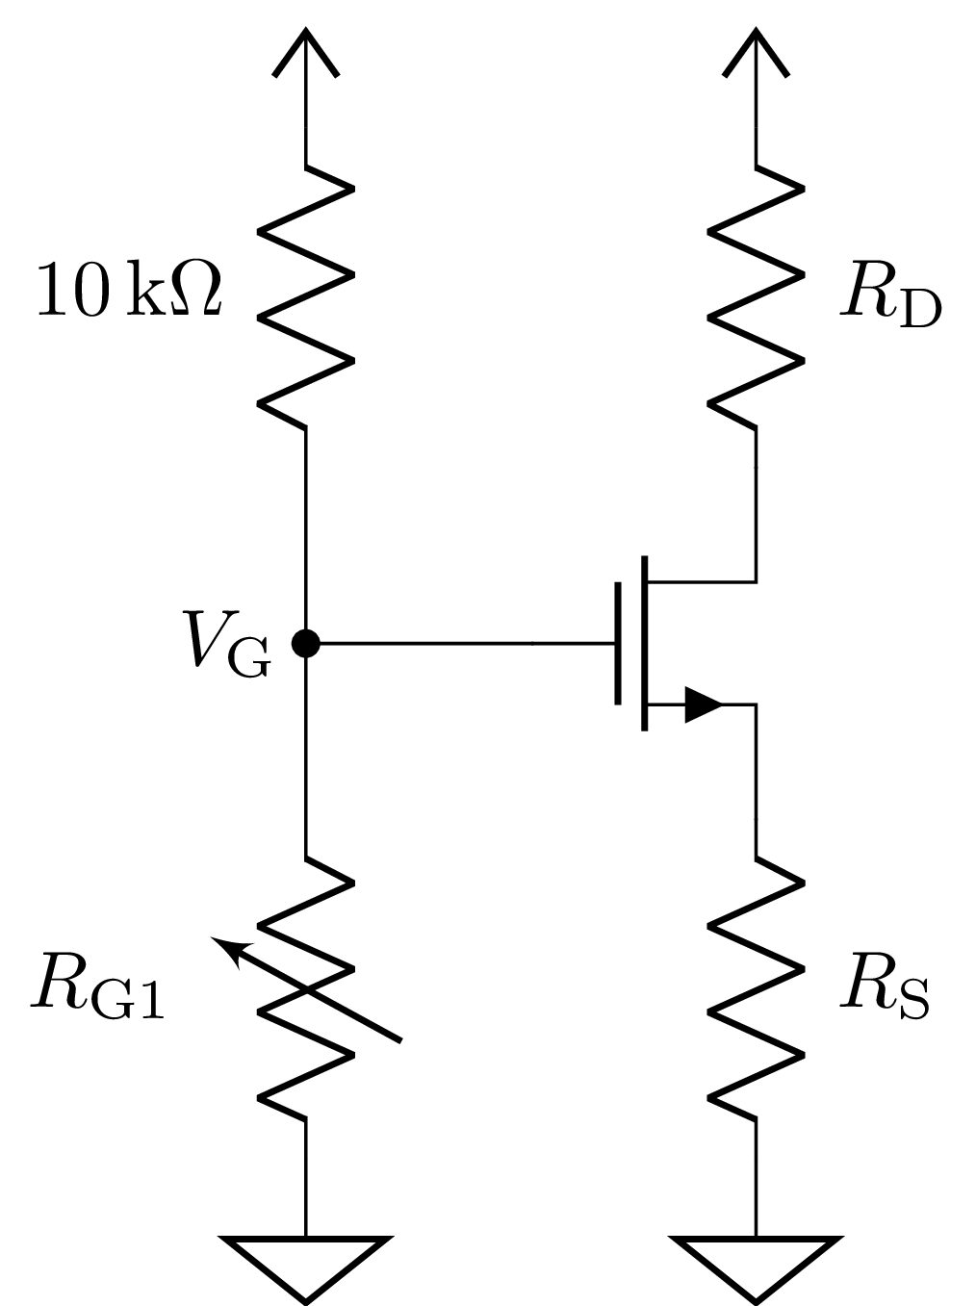
Figure L4.3: Biasing with a source resistor

- Repeat steps (b) and (d) for this circuit. Is the circuit more stable this time?
- Build the third biasing circuit as follow, with R_{D} calculated from the prelab to get 50 mA. Is this circuit stable when you change the transistor? Why do we not need to tune a potentiometer for this biasing scheme?
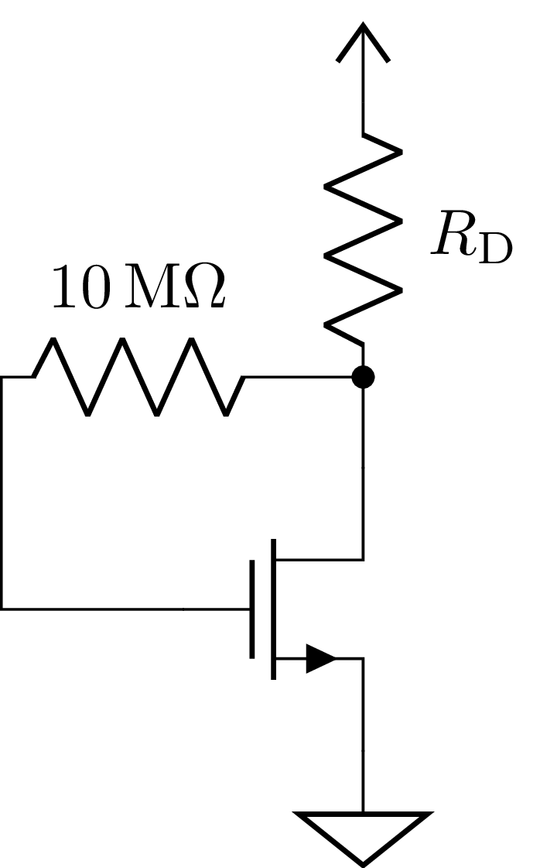
Figure L4.4: Biasing with feedback from the drain
- Knowing that the gain is set by the DC bias current in a MOS amplifier, what is the compromise with the simpler arrangement in the third circuit compared to the second circuit?
Hint: compare the voltage drop across the transistor and the resistors between both circuits, and discuss which circuit would be able to amplify larger signals without saturating.

Resistive touch sensor amplifier
In this part, we use the BS170 transistor to amplify the current from a resistive touch sensor.
- Implement the resistive touch sensor circuit in Figure 6 on the breadboard. Use the LED as an indicator. Make sure to change V_{DD} to 3 V.
- Measure the gate voltage, the drain voltage, the source voltage and the drain current for before and after touching. Identify the region of operation of the transistor for each case.
- Do the measured values match with your calculated values?
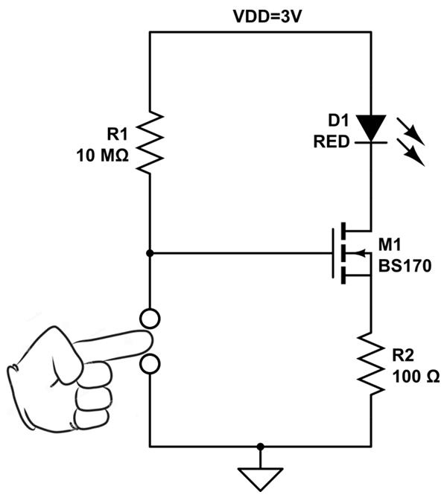
Figure L4.5: Resistive touch sensor amplifier

Laboratory 4: Biasing of MOS Transistors
Results Sheet for Laboratory Exercises
NAME: LAB SECTION:

MOS transistor characterization
- Attach a plot the drain current versus the gate voltage.

Threshold voltage: ____________

Required voltage to get 50 mA of drain current: ____________

k_{n} for this transistor: ____________

MOS biasing circuits
- R_{D}: ____________
- Is it easy to achieve accurate control? As the transistor heats up with time, does the current stay stable?

- R_{G1}: ____________
R_{G2}: ____________
V_{GS}: ____________
Compare with the measurement in part 1.

- Variation in drain current between the two transistors: ____________
- R_{S}: ____________
R_{D}: ____________
- Is it easy to achieve accurate control? As the transistor heats up with time, does the current stay stable?

Variation in drain current between the two transistors: ____________
- Is this circuit stable when you change the transistor? Why do we not need to tune a potentiometer for this biasing scheme?

- What is the compromise with the simpler arrangement in the third circuit compared to the second circuit?

Resistive touch sensor amplifier
- Measured values:

 | VG | VD | VS | ID | Region of operation
Before touching
After touching

- Do these measured values match with your calculated values from the prelab?

